OOPs Assignment

1.A student management system needs to create student objects with different details. Some students have only a name, while others have a name and age.
Write a Java program using constructor overloading to create student objects with different sets of information.
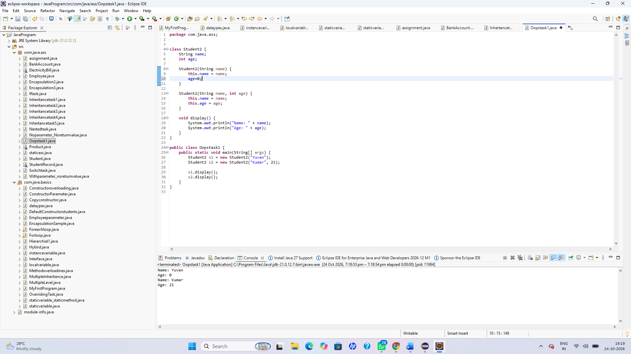

2.A calculator application performs addition for two integers and two decimal numbers. Another application requires different employee types to calculate bonuses differently.
Write a Java program demonstrating method overloading and method overriding.
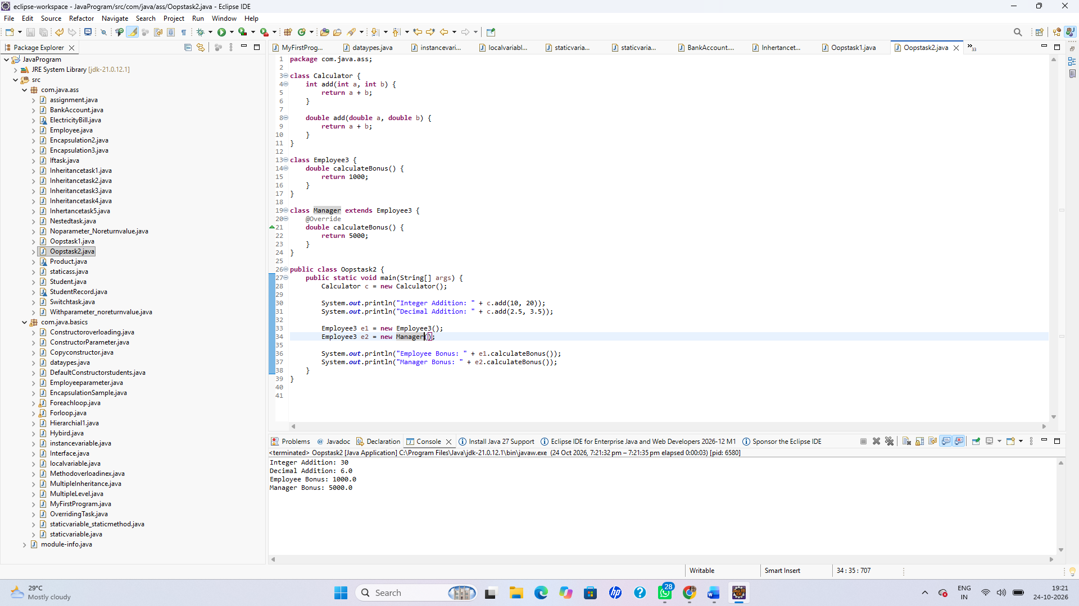

3. A banking application stores an account holder's name and balance. The balance should not be modified directly from outside the class, and withdrawals must not exceed the available balance.
Implement encapsulation using private variables, getters, setters where appropriate, and a withdrawal method.
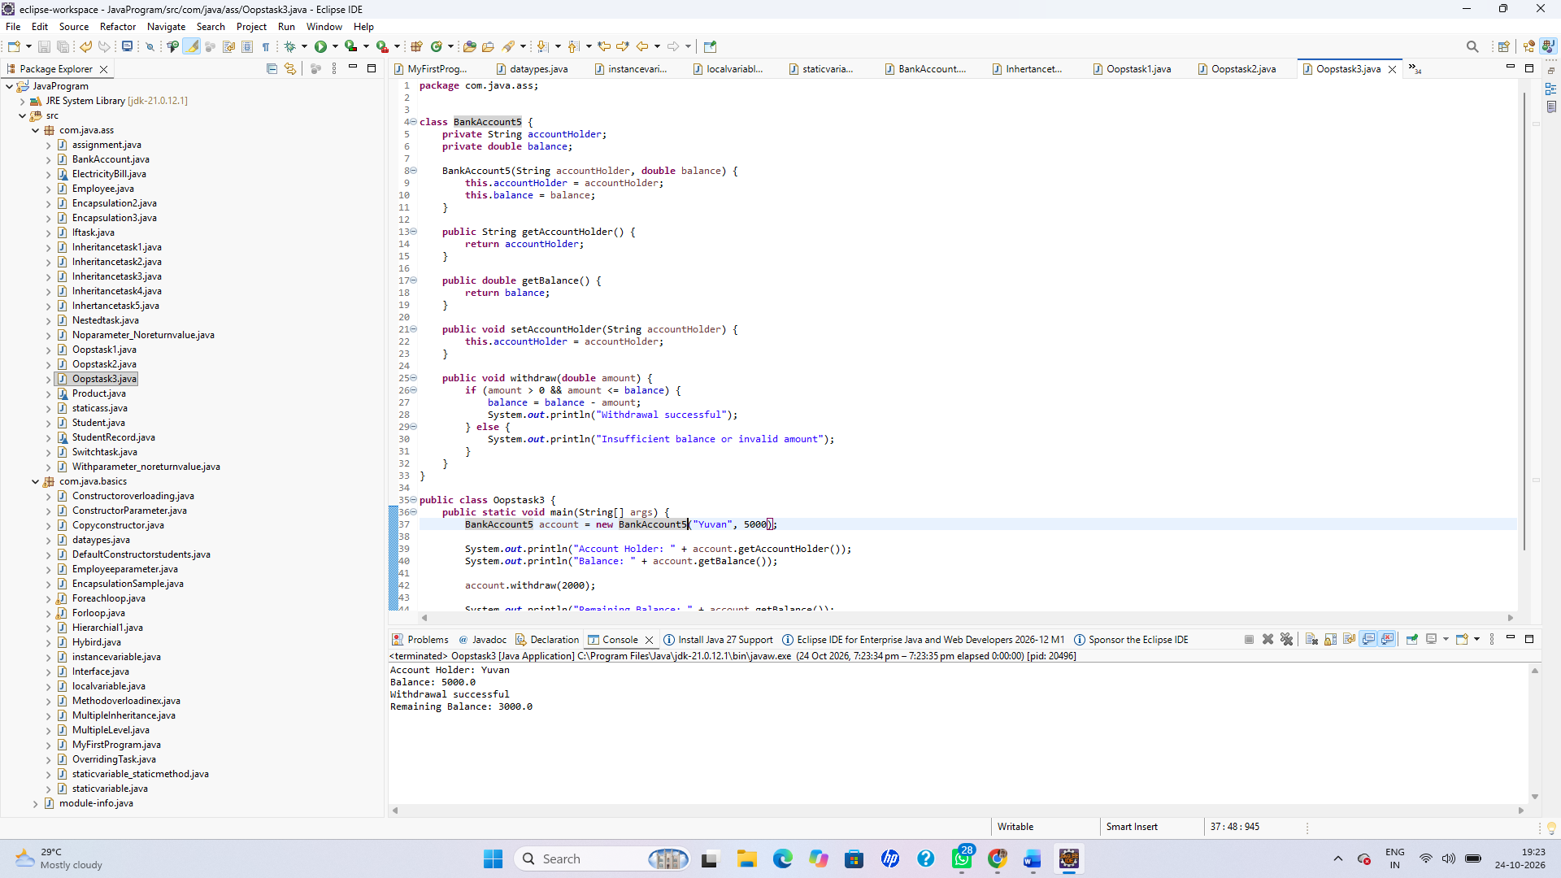

4. A company has different employee types: Developer and Manager. Both share common employee details, but each has a different responsibility description.
Write a Java program using inheritance and method overriding to display the responsibilities of each employee type.
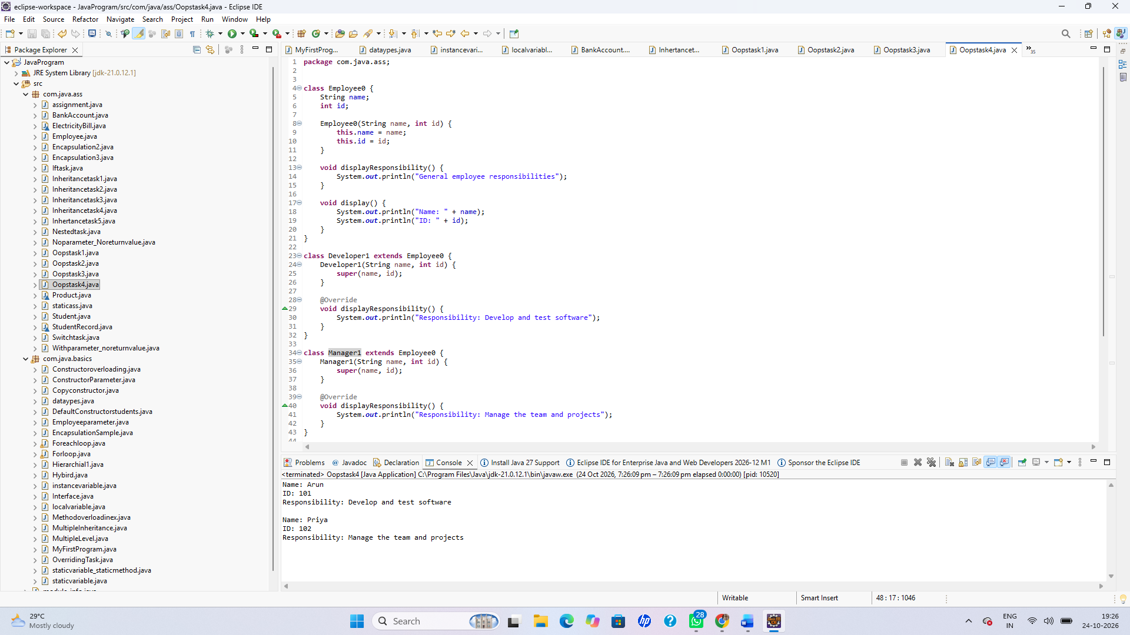

5. An online payment application supports UPI and credit card payments. Both payment methods must implement a common payment operation, but their processing logic differs.
Create an abstract class named Payment with an abstract method processPayment(). Implement it in UPIPayment and CreditCardPayment classes and demonstrate runtime polymorphism.
